Experiment Number : 04 Date: 05.02.2026

ARRAYS
Aim:
To understand and implement array operations in Java.
PRE LAB EXERCISE
QUESTIONS
- What is an array?
An array is a data structure that stores multiple values of the same type in a single variable, arranged in continuous memory locations.
Example in Java:
int marks[] = {90, 85, 70, 60}; Here, marks is an array storing 4 integers.
- Why are arrays used?
Arrays are used because:
To store multiple values using one variable.
Easy to access values using index numbers (0, 1, 2…).
Better memory management than creating separate variables.
Helps in looping through data easily.
Useful for storing large amounts of related data (marks, ages, prices, etc.).
- What is the difference between array and variable?
A variable can store only one value at a time, while an array can store multiple values of the same data type using a single name. A variable occupies its own memory location, whereas an array uses continuous memory locations to store all its elements. In a variable, the value is accessed directly using the variable name, but in an array, each value is accessed using an index such as a[0], a[1], and so on.

IN LAB EXERCISE
Objective:
To perform array operations using simple programs.
PROGRAMS:
1. Program to Read and Print Array Elements
Code:
import java.util.Scanner;
public class ReadPrintArray {
public static void main(String[] args) {
Scanner sc = new Scanner(System.in);
int[] arr = new int[5];
System.out.println("Enter 5 elements:");
for(int i = 0; i < 5; i++)
arr[i] = sc.nextInt();
System.out.println("Array elements are:");
for(int i = 0; i < 5; i++)
System.out.print(arr[i] + " ");
}
}
OUTPUT:
Input:
10 20 30 40 50
Output:
Array elements are:
10 20 30 40 50
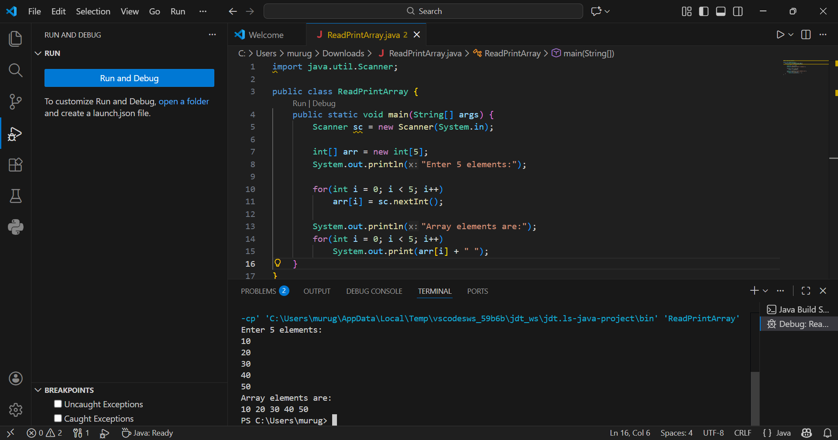
2. Program to Find Sum of Array Elements
Code:
import java.util.Scanner;
public class SumArray {
public static void main(String[] args) {
Scanner sc = new Scanner(System.in);
int[] arr = new int[5];
int sum = 0;
System.out.println("Enter 5 elements:");
for(int i = 0; i < 5; i++)
arr[i] = sc.nextInt();
for(int i = 0; i < 5; i++)
sum += arr[i];
System.out.println("Sum = " + sum);
}
}
OUTPUT:
Input:
5 10 15 20 25
Output:
Sum = 75
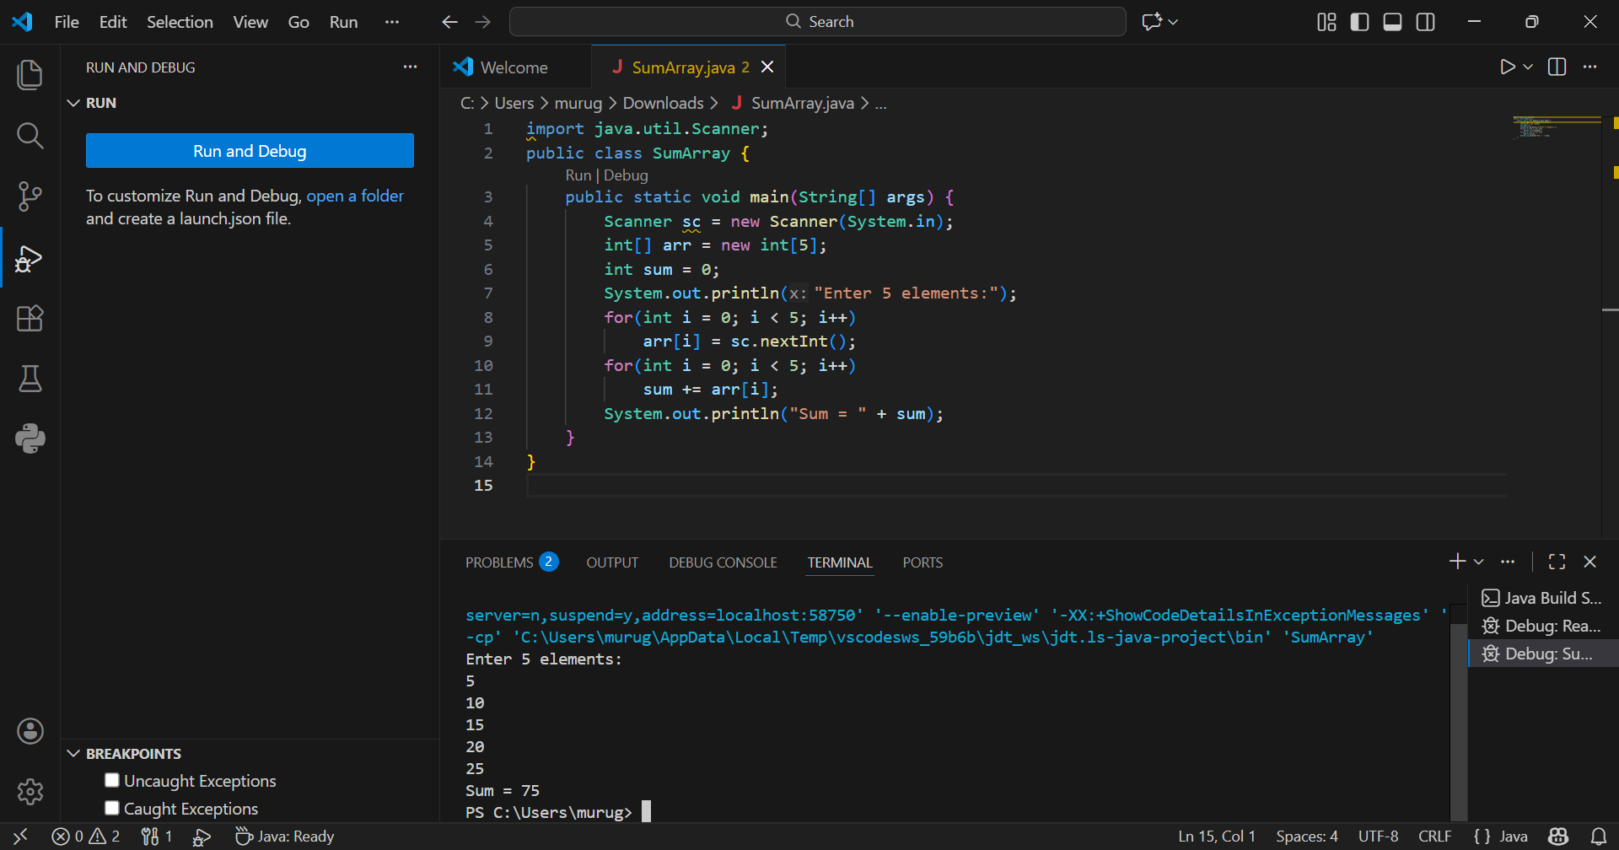
3. Program to Find Largest Element in an Array
Code:
import java.util.Scanner;
public class LargestElement {
public static void main(String[] args) {
Scanner sc = new Scanner(System.in);
int[] arr = new int[5];
System.out.println("Enter 5 elements:");
for(int i = 0; i < 5; i++)
arr[i] = sc.nextInt();
int max = arr[0];
for(int i = 1; i < 5; i++)
if(arr[i] > max)
max = arr[i];
System.out.println("Largest element = " + max);
}
}
OUTPUT:
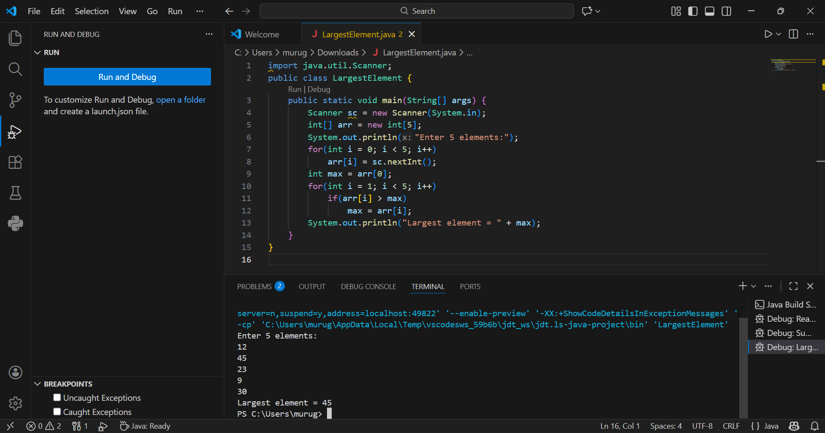
Input:
12 45 23 9 30
Output:
Largest element = 45

4. Program to Reverse an Array
Code:
import java.util.Scanner;

public class ReverseArray {
public static void main(String[] args) {
Scanner sc = new Scanner(System.in);
int[] arr = new int[5];
System.out.println("Enter 5 elements:");
for(int i = 0; i < 5; i++)
arr[i] = sc.nextInt();
System.out.println("Reversed array:");
for(int i = 4; i >= 0; i--)
System.out.print(arr[i] + " ");
}
}
OUTPUT:
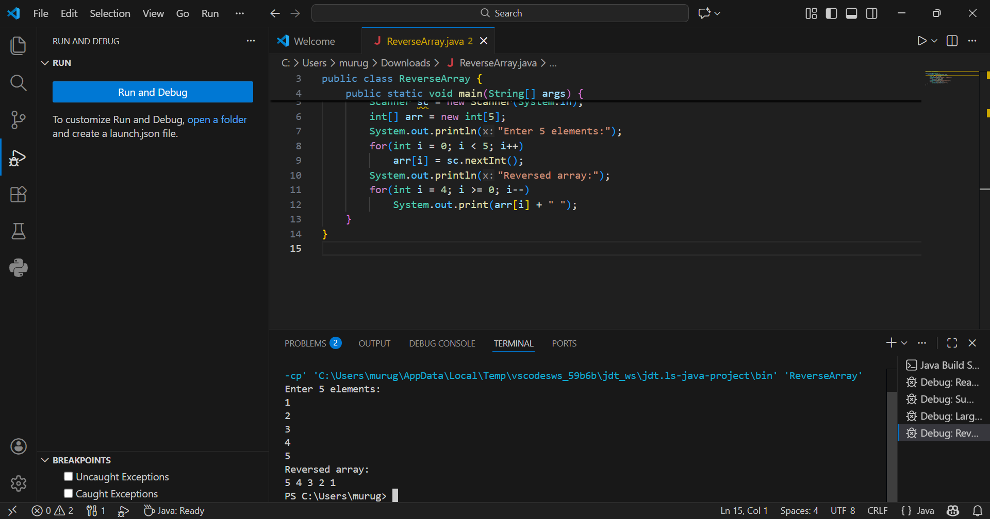
Input:
1 2 3 4 5
Output:
Reversed array:
5 4 3 2 1

5. Program to Count Even and Odd Numbers
Code:
import java.util.Scanner;
public class EvenOddCount {
public static void main(String[] args) {
Scanner sc = new Scanner(System.in);
int[] arr = new int[5];
int even = 0, odd = 0;
System.out.println("Enter 5 elements:");
for(int i = 0; i < 5; i++)
arr[i] = sc.nextInt();
for(int i = 0; i < 5; i++) {
if(arr[i] % 2 == 0)
even++;
else
odd++;
}

System.out.println("Even = " + even);
System.out.println("Odd = " + odd);
}
}
OUTPUT:
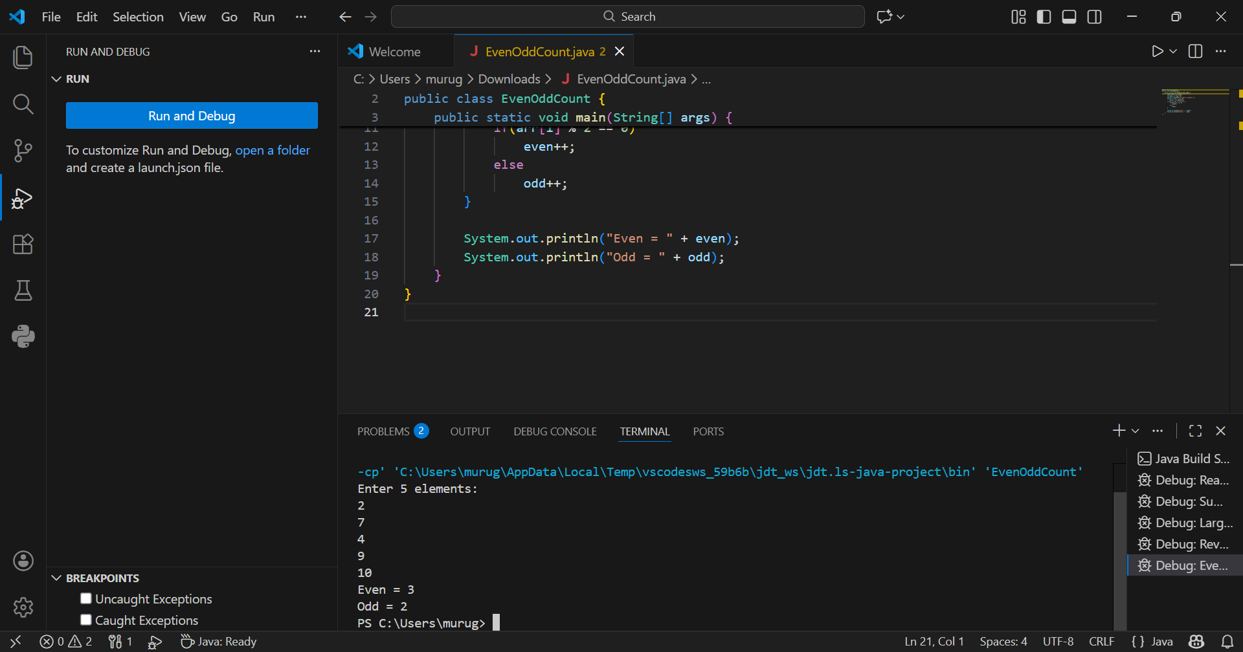
Input:
2 7 4 9 10
Output:
Even = 3
Odd = 2

6. Program to Sort Array in Ascending Order
Code:
import java.util.Scanner;
public class SortArray {
public static void main(String[] args) {
Scanner sc = new Scanner(System.in);
int[] arr = new int[5];
int temp;
System.out.println("Enter 5 elements:");
for(int i = 0; i < 5; i++)
arr[i] = sc.nextInt();
for(int i = 0; i < 5; i++) {
for(int j = i + 1; j < 5; j++) {
if(arr[i] > arr[j]) {
temp = arr[i];
arr[i] = arr[j];
arr[j] = temp;
}
}
}
System.out.println("Sorted array:");
for(int i = 0; i < 5; i++)
System.out.print(arr[i] + " ");
}
}
OUTPUT:
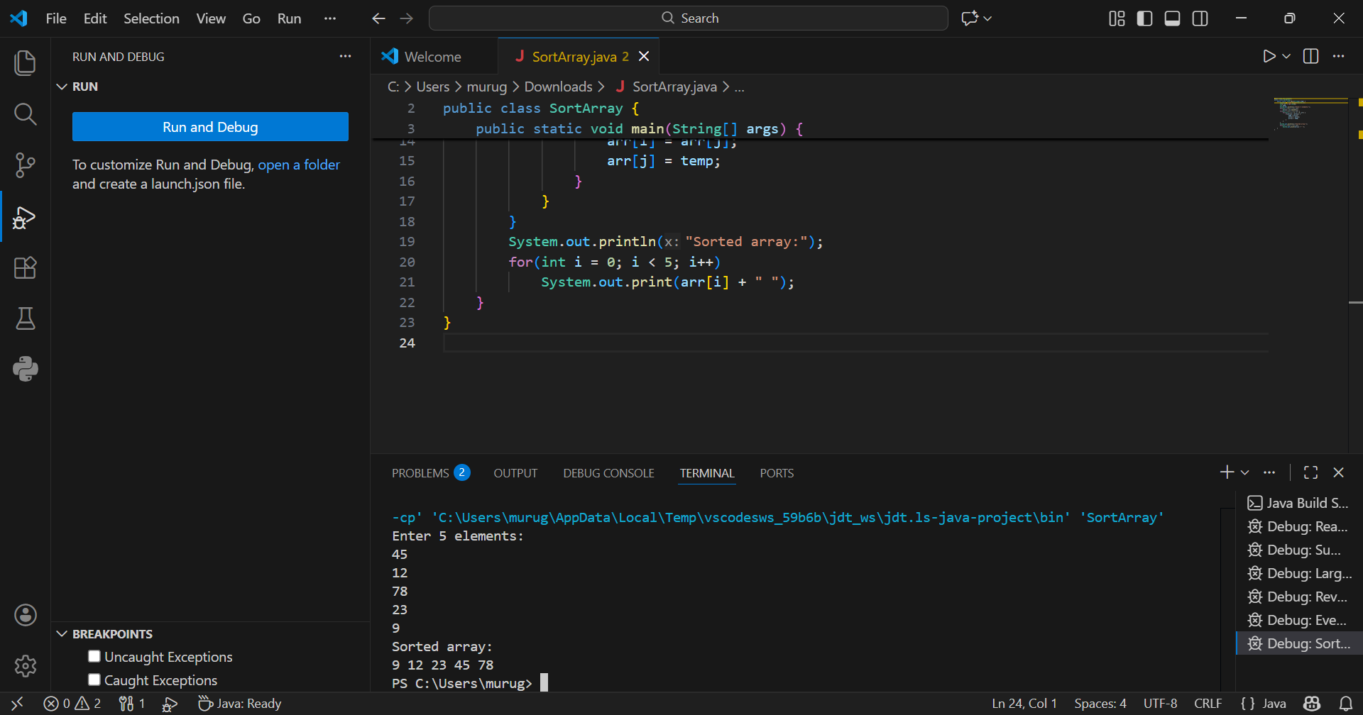
Input:
45 12 78 23 9
Output:
Sorted array:
9 12 23 45 78

7. Program to Find Second Largest Element
Code:
import java.util.Scanner;
public class SecondLargest {
public static void main(String[] args) {
Scanner sc = new Scanner(System.in);
int[] arr = new int[5];

System.out.println("Enter 5 elements:");
for(int i = 0; i < 5; i++)
arr[i] = sc.nextInt();
int largest = arr[0];
int second = arr[0];
for(int i = 0; i < 5; i++) {
if(arr[i] > largest) {
second = largest;
largest = arr[i];
}
}
System.out.println("Second largest = " + second);
}
}
OUTPUT: 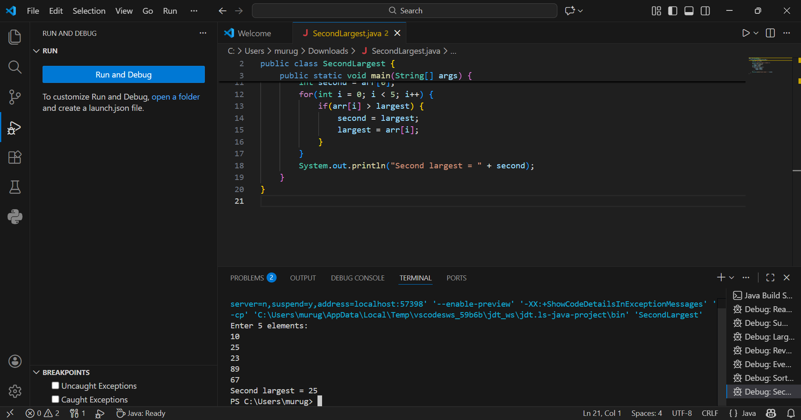
Input:
10 45 23 89 67
Output:
Second largest = 67

8. Program for Matrix Addition (2D Array)
Code:
import java.util.Scanner;
public class MatrixAddition {
public static void main(String[] args) {
Scanner sc = new Scanner(System.in);
int[][] a = new int[2][2];
int[][] b = new int[2][2];
int[][] sum = new int[2][2];
System.out.println("Enter elements of matrix A:");
for(int i = 0; i < 2; i++)
for(int j = 0; j < 2; j++)
a[i][j] = sc.nextInt();
System.out.println("Enter elements of matrix B:");
for(int i = 0; i < 2; i++)
for(int j = 0; j < 2; j++)
b[i][j] = sc.nextInt();
for(int i = 0; i < 2; i++)
for(int j = 0; j < 2; j++)
sum[i][j] = a[i][j] + b[i][j];
System.out.println("Sum matrix:");
for(int i = 0; i < 2; i++) {
for(int j = 0; j < 2; j++)
System.out.print(sum[i][j] + " ");
System.out.println();
}
}
}
OUTPUT: 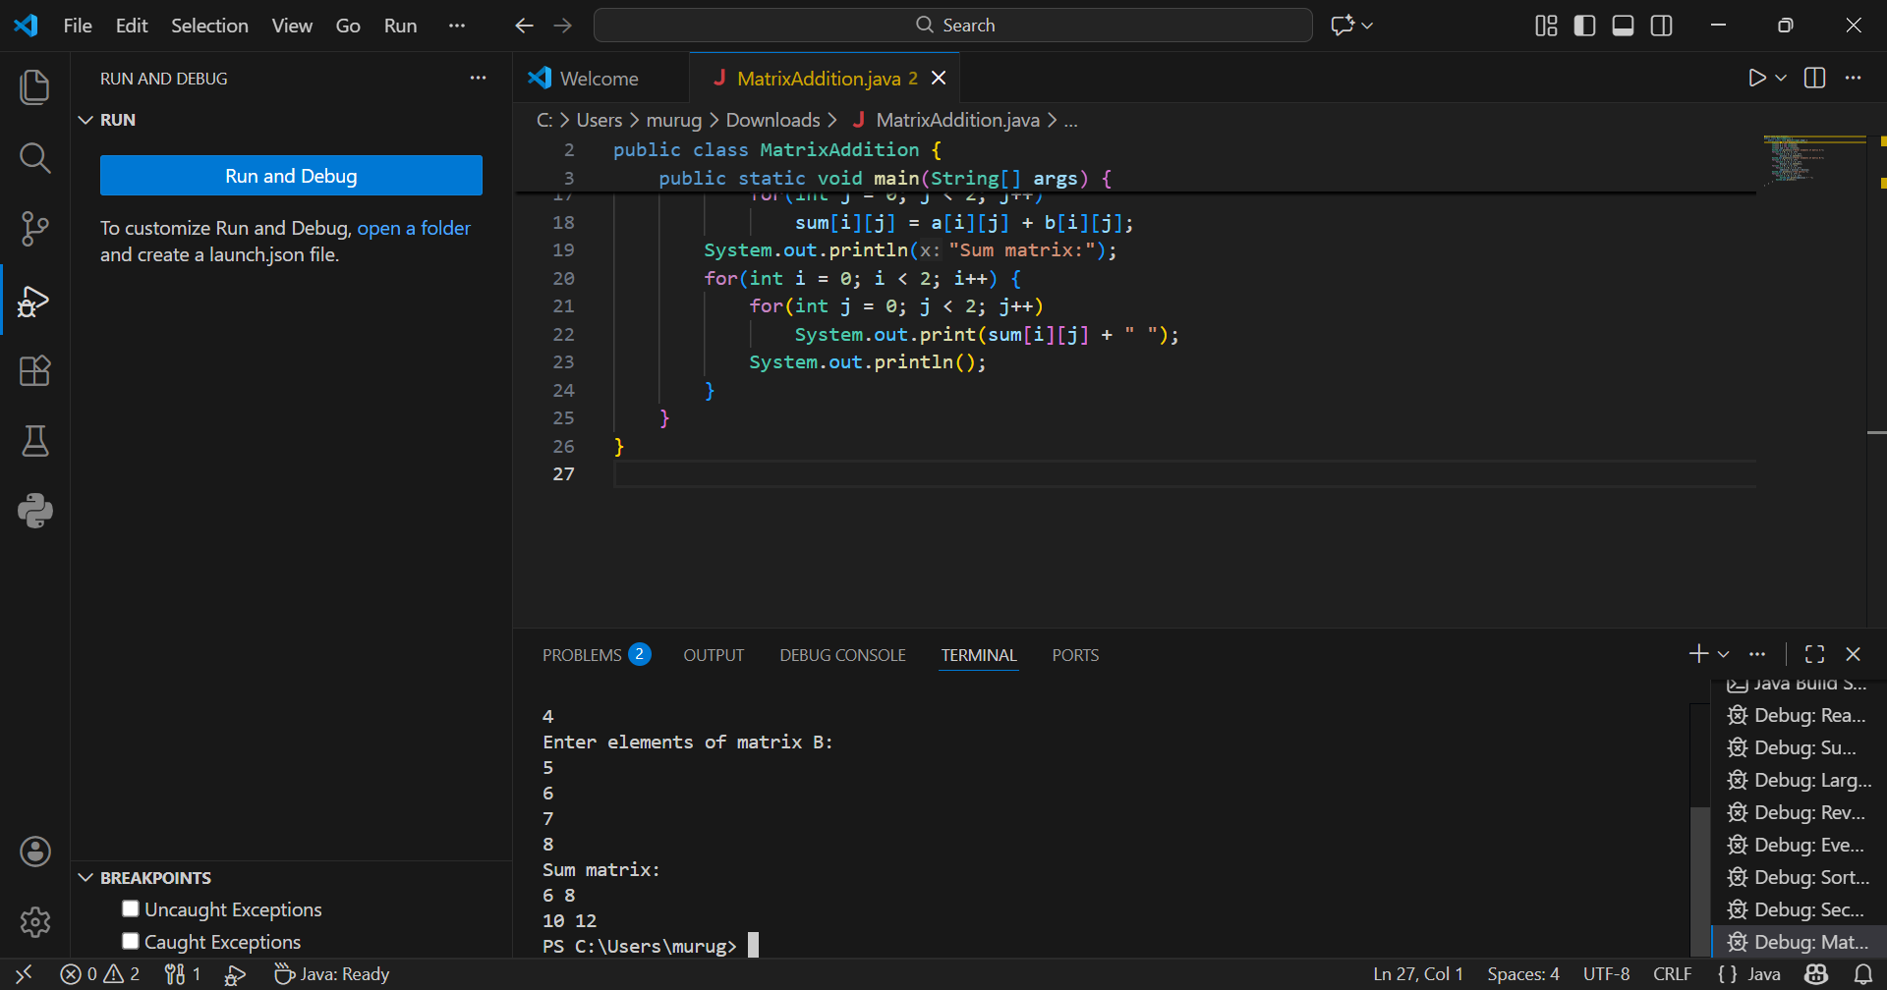
Matrix A:
1 2
3 4
Matrix B:
5 6
7 8
Sum matrix:
6 8
10 12

POST LAB EXERCISE
- Why is array indexing usually started from zero instead of one?
Array indexing starts from zero because the index represents the offset from the base address. The first element is stored exactly at the base address, so its offset is 0, which makes address calculation simple and fast.
- What happens if we try to access an array element outside its declared size?
Accessing an element outside the array size leads to invalid memory access. In languages like C/C++, it may cause wrong values or crashes. In Java, it throws an ArrayIndexOutOfBoundsException to prevent errors.
- How does memory allocation differ for static arrays and dynamic arrays?
Static arrays have a fixed size and are allocated in contiguous memory at compile-time or program start. Dynamic arrays are allocated at runtime, stored in heap memory, and can grow or shrink as needed.
- Why is searching faster in arrays compared to linked lists?
Arrays are faster for searching because elements are in contiguous memory, allowing direct access using indexes. Linked lists store elements in different locations, so they must be traversed one by one, making searching slower.
- What is the difference between contiguous and non-contiguous memory allocation?
Contiguous memory stores elements next to each other, giving fast index-based access (like arrays). Non-contiguous memory stores elements in separate locations linked by pointers (like linked lists), giving more flexibility but slower access.

Result:

Thus the array operations were executed successfully.

ASSESSMENT

Description | Max Marks | Marks Awarded
Pre Lab Exercise | 5
In Lab Exercise | 10
Post Lab Exercise | 5
Viva | 10
Total | 30
Faculty Signature

